# Christina Jimenez

# CS 255 System Design

**26 April 2024**

## UML Diagrams

### UML Use Case DiagramBlank diagram-4.pdf

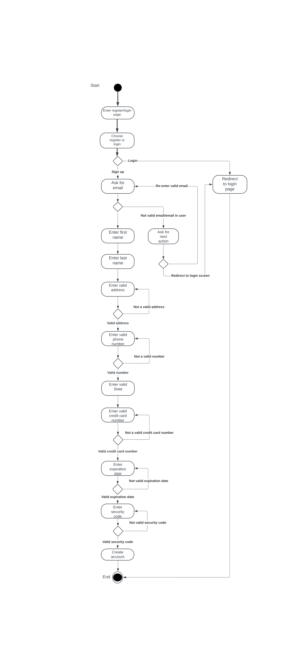

### UML Activity Diagrams

### Blank diagram-6.pdf

### Sequence diagram.pdf

### UML Sequence Diagram

### UML Class DiagramBlank diagram-7.pdf

## Technical Requirements

**Interface Needs:**

* Needs to manage user accounts, schedules, and system settings
* Needs to be able to schedule appointments, manage customer information, and provide customer support
* Needs to allow users to view assigned schedules, progress, customer details, and feedback.
* Needs to be able to register students for packages, schedule lessons, access learning materials, and make payments

**Users and Needs:**

* Administrator : System management, configuration, monitoring, and reporting.
* Receptionist: Appointment scheduling and customer management
* Instructors: Schedule management, lesson updates, feedback
* Customers (Students): Package registration, appointment scheduling, access to resources, payment management

**Interface Platforms:**

* Browser-Based: Accessible via web browsers on desktops, laptops, and tablets.
* Mobile Application: iOS and Android apps for smartphone access.
* Responsive Design: Optimized for various screen sizes and resolutions.